Your Step-by-Step Guide to Applying


for UA Cossatot

We are SO excited that you are considering joining our college family! Whether you are dreaming big, exploring your options, or just starting your journey, we’ re here to cheer you on every step of the way. Applying to college can feel like a big leap – but don’t worry we have your back! This guide is here to help make the process smooth and simple.
If you have any questions as you are filling out your application, please let us know. You can email us at StudentServices@cccua.edu or call us at 1-800-844-4471 and ask for Student Services.
Pro Tips
- We encourage all applicants to watch the short video with the step-by-step process prior to starting their application. (You can also access the video on our website.)
https://youtu.be/F2F-ihcxw2s?si=jTC6JXezff5imsmo
- When applying we highly recommend using a computer instead of a cell phone.
- Any field with a red asterisk (*) next to it MUST be filled out.
- If you start an application and need to pause or come back to it later, that is okay! Login into your Workday account, click the home button, and choose “My Application in Progress” and resume your application.

Step 1: Getting to our application
Go to https://www.cccua.edu/ and select “Apply & Enroll”. A drop-down menu will appear, select “How to Apply & Enroll”. This will take you to a new page. Scroll down to step 1 and click the hyperlink in red “Apply Now”.
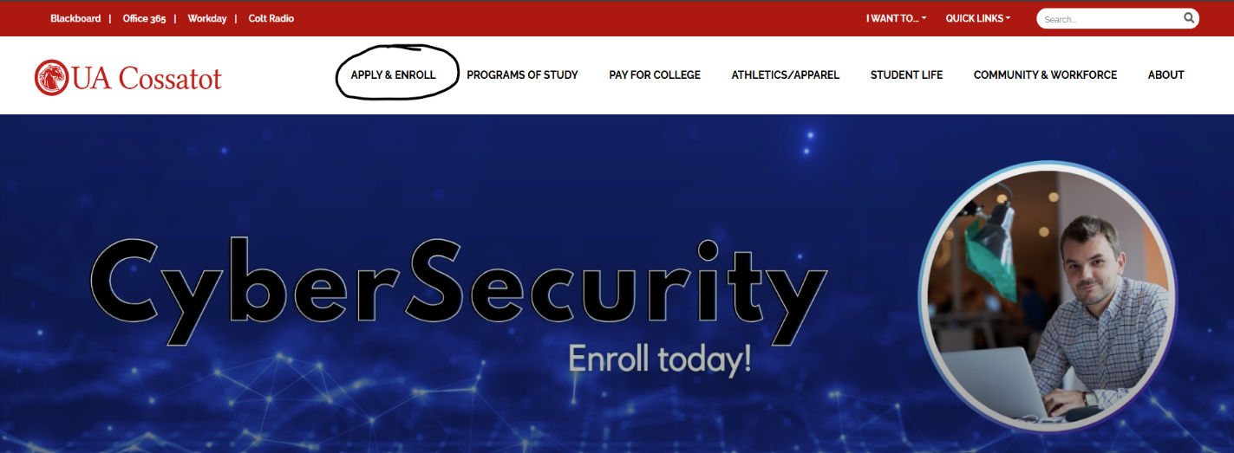

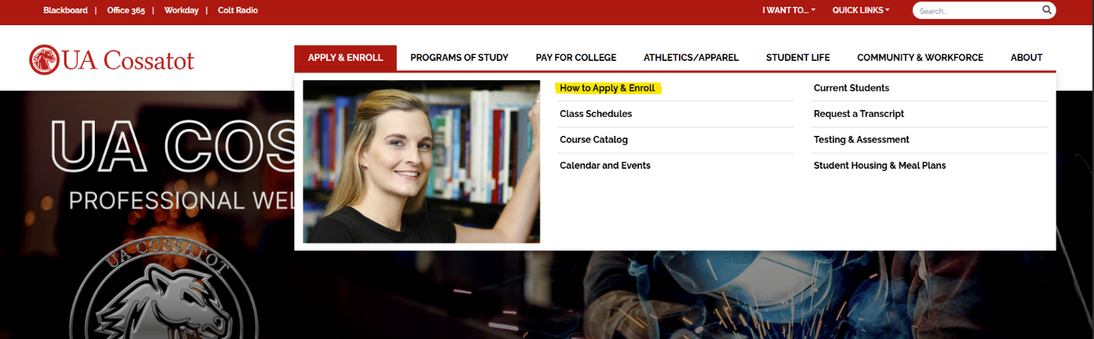

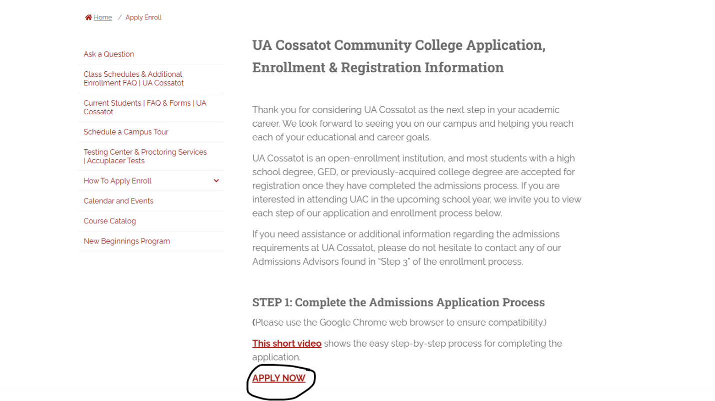

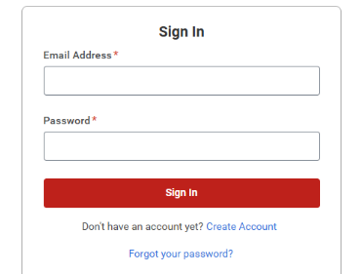
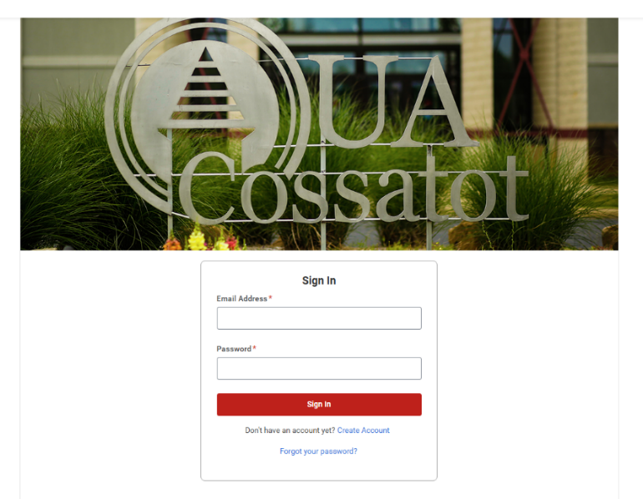
- If the hyperlink to the step-by-step video link above in the Pro Tips section does not work, you can also access the video on this page above the Apply Now hyperlink.

Step 2: Creating Your Workday Account
After selecting “Apply Now” it will take you to the home page of Workday. You will need to create your account for Workday. The “Create Account” hyperlink will be in blue under the sign in button. Once you have added your email and created a password, select create account. Before signing into your new Workday account, it will ask you to verify your account. Go to the email address you used in creating your account, you should receive one from UA System Workday Info.
Please note that this link will expire after 24 hours.
- Pro Tip: Use an email address that you use often. You will receive emails from UA Systems and Workday with further information once you have submitted your application. (They may appear in your junk/ spam email folder.)
- Pro Tip: IF you are a returning student, please DO NOT use your school email address. If you do remember the email address used previously, you can choose Forget your password to reset it and then sign in.
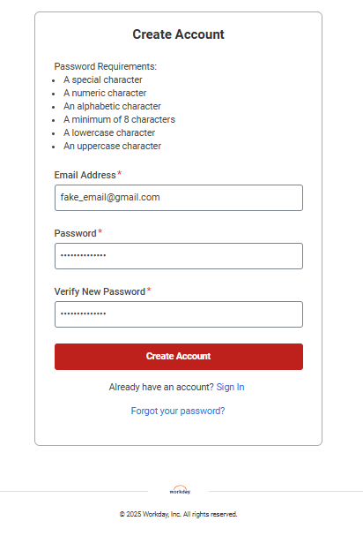
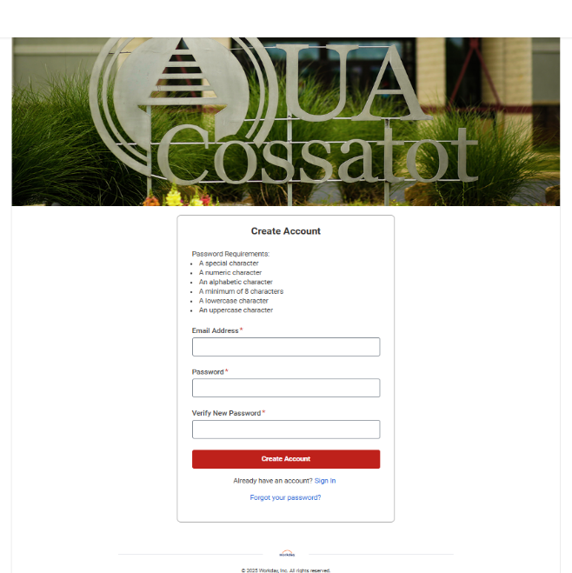

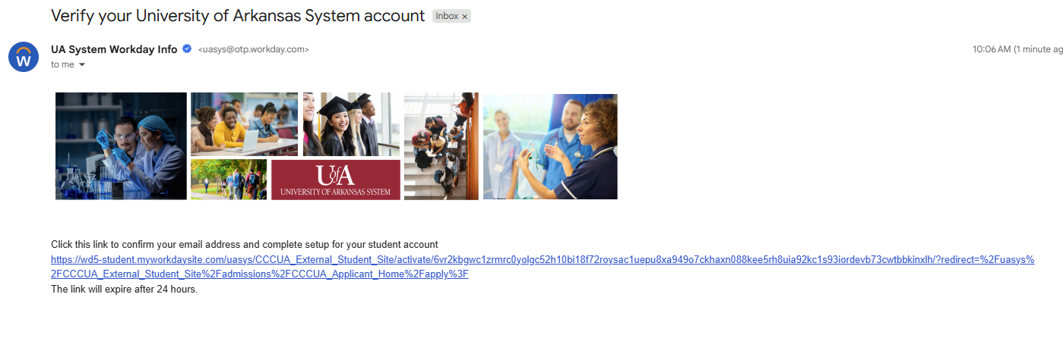
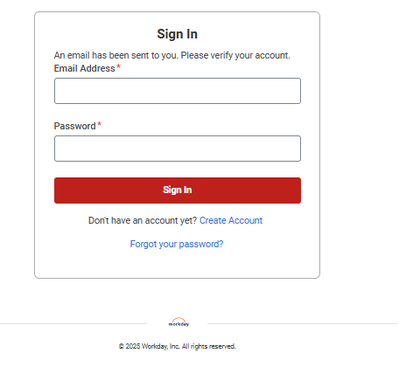

When you click on the hyperlink from the email it will bring you back to the Workday sign in page. Above Email Address in Italics, it should say Account Activated. Go ahead and sign back into your account and select the sign in button.
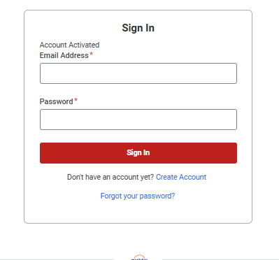

Step 3: Filling out the Application
- Please note this a general example and what is selected on the application may not match your application completely.
- Everything with red asterisk (*) next to it MUST be completed.
Read the description for Applicant Type to see which best applies.
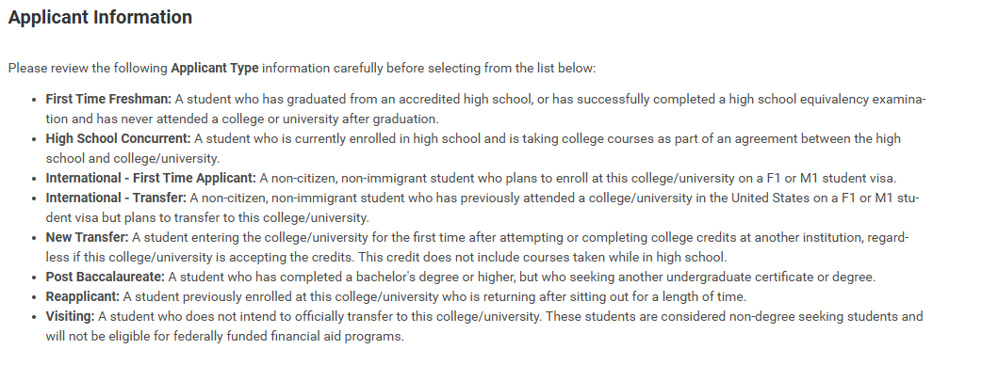

Applicant Information
In applicant information you will need to answer every question before proceeding to the next page.
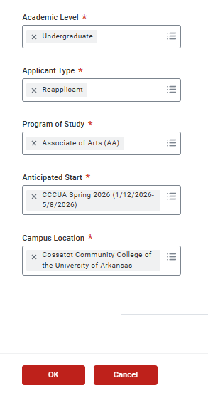
Academic Level: Undergraduate (everyone will choose this one.)
Applicant Type: (Please read the description and select which applies best to you.)
Program of Study: (Select the program of your choice.)
Anticipated Start: (Pick which semester you want to start taking classes.)
Campus Location: Cossatot Community College of the University of Arkansas (everyone will choose this one.)

Each box has a drop-down option to select your answer.

Application Overview: Personal Information
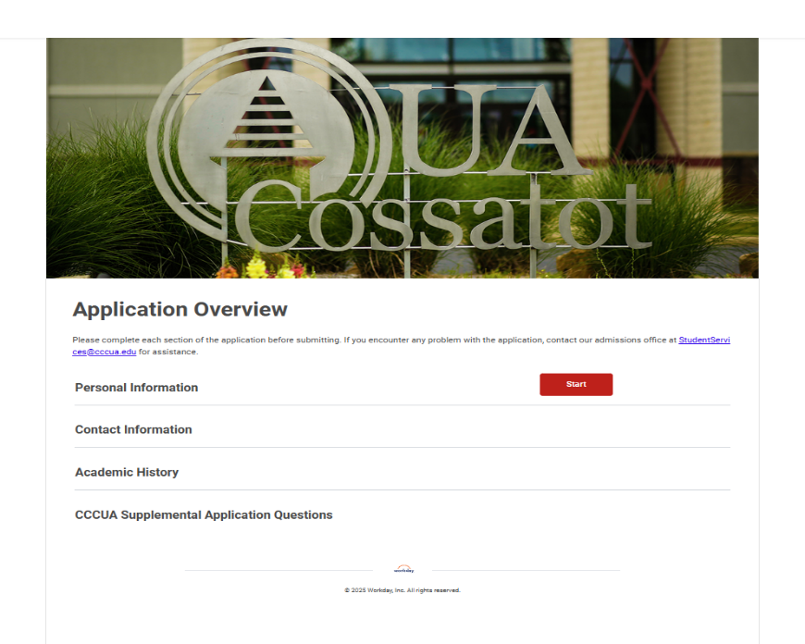
We will start with the Personal Information Section. Click on the red Start button to begin.

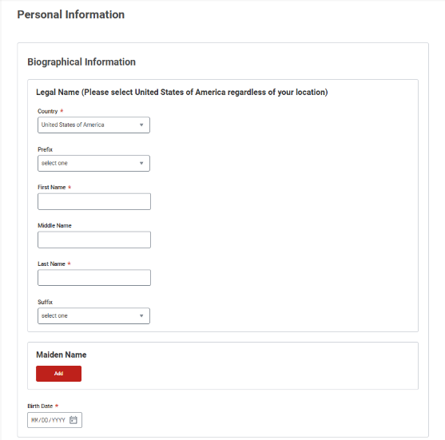
Please fill out this information
with your legal name!
Country: must fill out
Prefix: (only if you have a doctorate degree)
First Name:
Middle Name:
Last Name:
Suffix: (only if you have a suffix with your name like Sr. or III)
Birth Date: mm/dd/yyyy format
If you have a maiden name you will need to select “Add” under maiden name and follow the prompts.

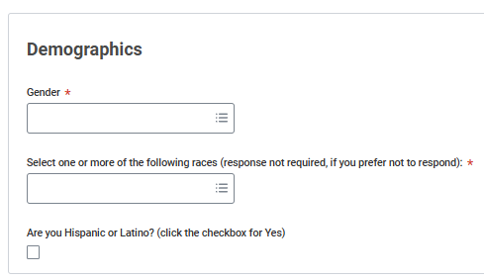
Demographics
Gender: use the drop-down button to make selection.
If you wish to answer the next question you can use the drop-down button and select all that apply OR you can select the box for yes if you are Hispanic or Latino.

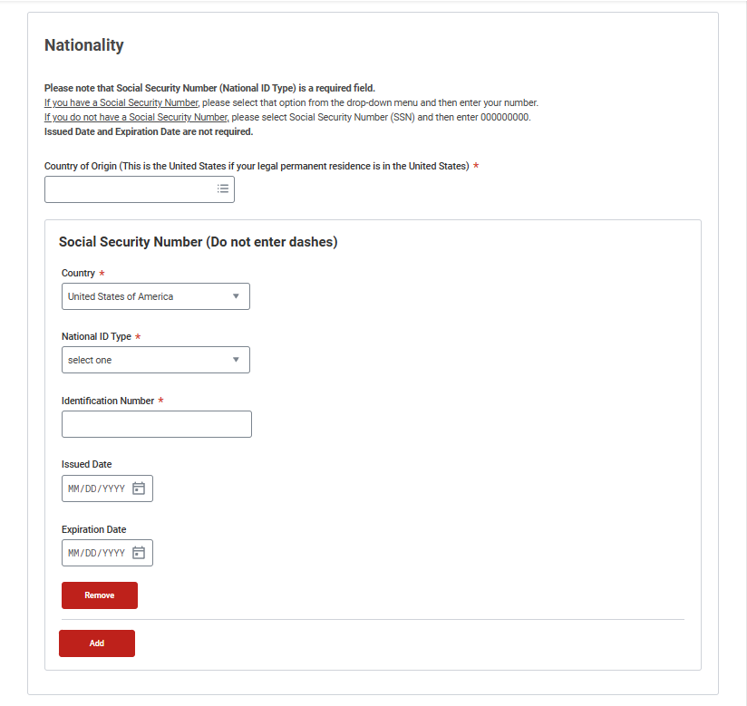
Nationality
Country of Origin: can use drop-down option or you can type the country and hit enter to find the country faster.
Country: can use drop-down option or you can type the country and hit enter to find the country faster.
National ID Type: choose either SSN or ITIN
Identification Number: enter your ID number

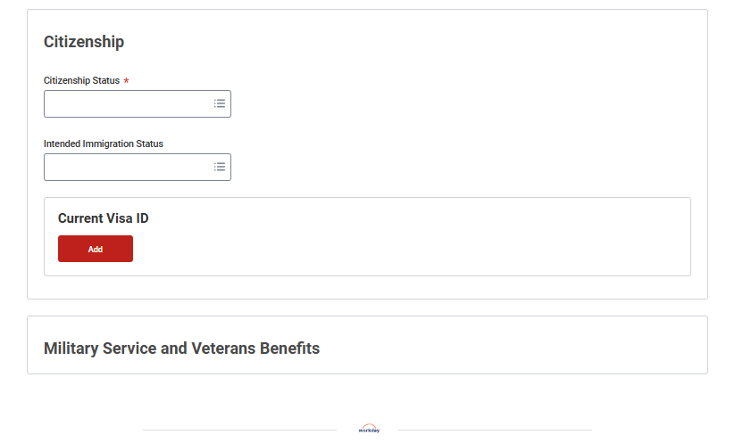

Citizenship
Citizenship Status: select from our drop-down options.
Choose Save and Continue at the bottom of the screen to start the next section.

Application Overview: Contact Information
After clicking the save and continue button it will take you back to the application overview page. We will start on the Contact Information section next. Click the Add button to begin.
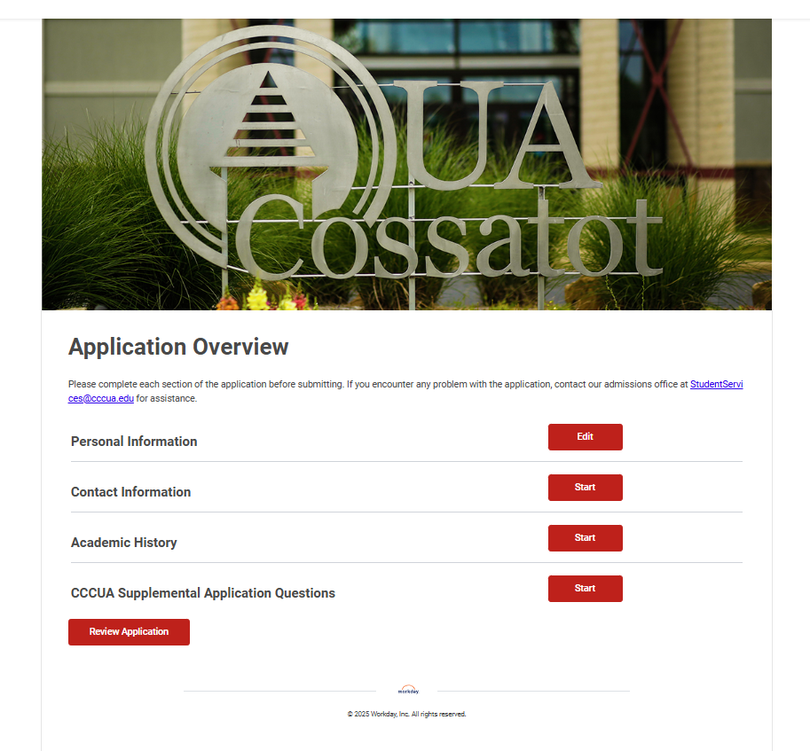

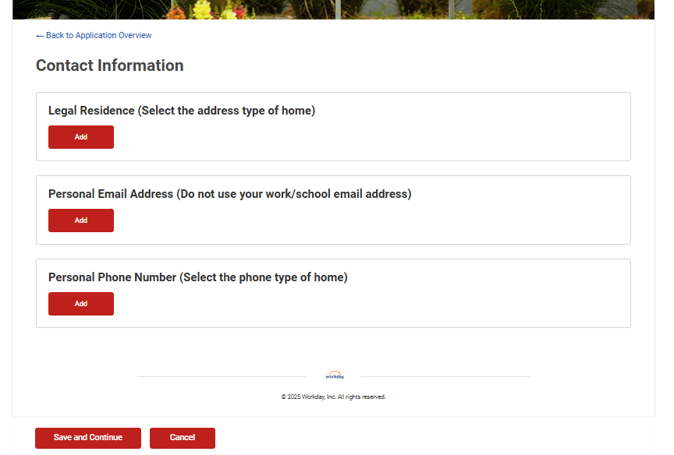

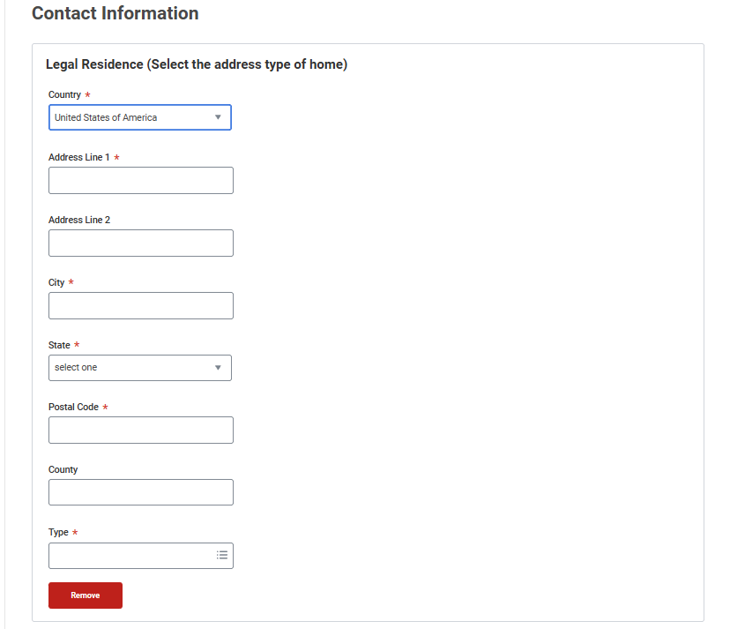
Country: can use drop-down option or you can type the country and hit enter to find the country faster.
Address Line 1:
Address Line 2:
City:
State: use drop arrow to select state
County: type in county
Type: select Home

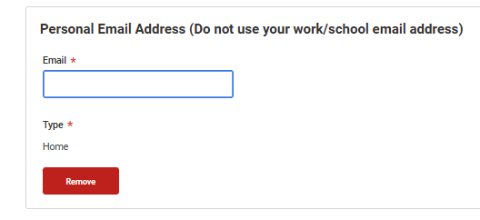
It should already have your email from creating account. If not enter the email you used when making your Workday account.

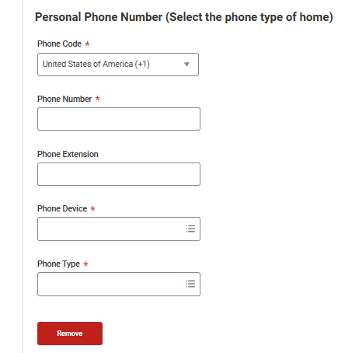
Phone Code: can use drop-down option or you can type the country and hit enter to find the country faster.
Phone Number: include the area code.
Phone Extension:
Phone Device:
Phone Type:

Application Overview: Academic History
If you have received a GED you will need to enter the Country of Educational Institution, and the Region of Educational Institution. Leave the City of Educational Institution blank, and for Institution Name enter the state you received your GED followed by GED. For example, if you got your GED in Texas you would enter “Texas GED”. Then enter everything else as normal.
If you are unsure about the exact start date, end date or graduation date enter a date closest to the time you think it is.
Any college you have attended aside from CCCUA must be included in your application. Use the Add button to add all the colleges.
Watch for boxes throughout each section if they apply select.

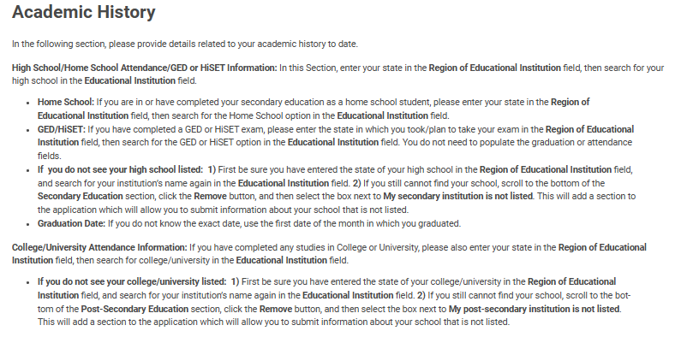

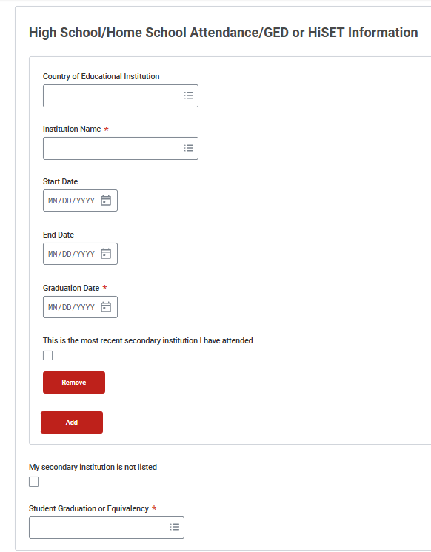

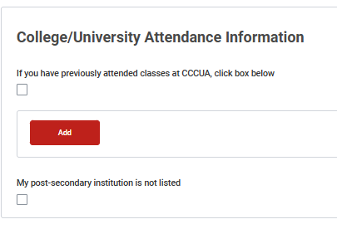

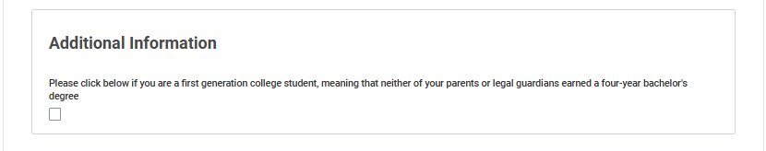

Application Overview: CCCUA Supplemental Application Questions
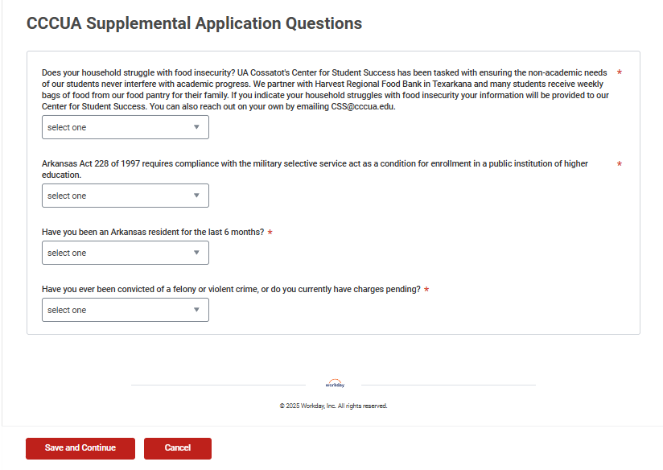
Use the drop-down menu to answer all questions. Once completed click on the Save and Continue button. You are almost done! Choose Review Application, make sure everything is right click I accept the Terms and Conditions and Submit Application.

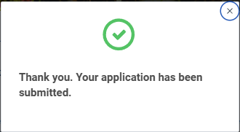
Thanks for applying to UA Cossatot we can’t wait to see you here!



How to Get Back to your Application
1)Go to cccua.edu, click Apply and Enroll and select How to Apply and Enroll.
2)Scroll down to step 1 and click Apply Now to access workday.
3)Login into your workday account. In the upper right-hand corner select Home.
4) The page should say Welcome {your name}. Under Admissions select the blue hyperlink: “Start or Access your CCCUA Application”.
5)The last step is to select your application under “Your Applications” to continue your application.

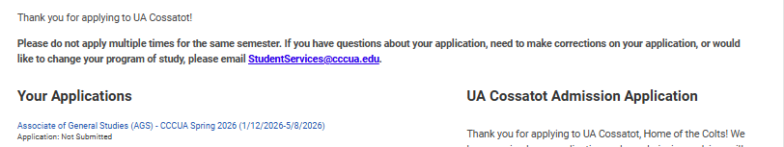
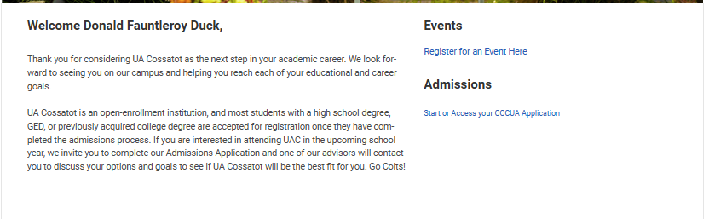
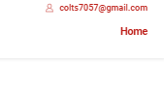
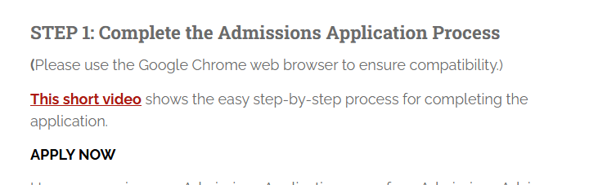
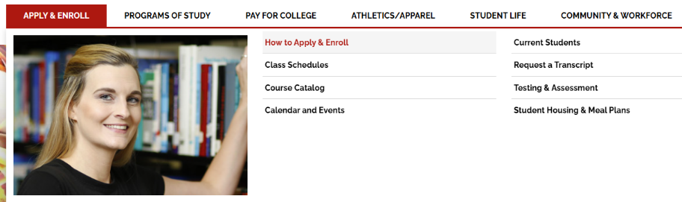
Step #5
Step #1
Step #4
Step #3
Step #2

